Abstract - These instructions give you basic guidelines for preparing papers for the IGC 2021 as part of the ICMEM 2021. Papers must be submitted using this format. This document is a template for Microsoft Word. If you are reading a paper version of this document, please download the electronic file from the Conference website so you can use it to prepare your manuscript. Abstract should not exceed 180 words. Please include appropriate key words in your abstract, in alphabetical order, separated by commas.

Keywords - Fonts, formatting, margins

I. INTRODUCTION

Your goal is to simulate, as closely as possible, the usual appearance of typeset papers in the ICMEM 2021.

II. LITERATURE REVIEW

All papers must be submitted electronically in MS Word format. Prepare your paper using a A4 page size of 210 mm × 297 mm (8.27" × 11.69").
1) Type sizes and typefaces: The best results will be obtained if your computer word processor has several type sizes. Try to follow the type sizes specified in Table I as best as you can. Use 14 point bold, capital letters for the title, 12 point Roman (normal) characters for author names and 10 point Roman characters for the main text and author's affiliations.
2) Format: In formatting your page, set top margin to 25 mm (1") and bottom margin to 31 mm (1 1/4”). Left and right margins should be 19 mm (3/4"). Use a two-column format where each column is 83 mm (3 1/4") wide and spacing of 6 mm (1/4") between columns. Indent paragraphs by 6 mm (1/4").
Left and right-justify your columns. Use tables and figures to adjust column length. Use automatic hyphenation and check spelling. All figures, tables, and equations must be included in-line with the text. Do not use links to external files.

A. Figures and Tables

Graphics should be in TIFF, 600 dpi (1 bit/sample) for line art (graphics, charts, drawings or tables) and 220 dpi for photos and gray scale images
Position figures and tables at the tops and bottoms of columns. Avoid placing them in the middle of columns. Large figures and tables may span across both columns. Figure captions should be below the figures; table names and table captions should be above the tables. Use the abbreviation “Fig.” even at the beginning of a sentence.
Figure axis labels are often a source of confusion. Try to use words rather than symbols. As an example, write the quantity “Magnetization,” or “Magnetization M,” not just “M.” Put units in parentheses. Do not label axes only with units. As in Fig. 1, for example, write “Magnetization (A/m)” or “Magnetization (Am⁻¹),” not just “A/m.” Do not label axes with a ratio of quantities and units. For example, write “Temperature (K),” not “Temperature/K.”
Multipliers can be especially confusing. Write “Magnetization (kA/m)” or “Magnetization (10³ A/m).” Do not write “Magnetization (A/m) × 1000” because the reader would not know whether the top axis label in Fig. 1 meant 16000 A/m or 0.016 A/m. Figure labels should be legible, approximately 10-point type.
Table 1. Type sizes for camera-ready papers

Type Size (pts) | Appearance
 | Regular | Bold |  | Italic
7 | Table captions ª
8 | Section titles, tables, table names ª, first letters in table captions ª, table superscripts, figure captions, text subscripts and superscripts,  references, footnotes
9 |  | Abstract
10 | Authors’ affliations, main text, equations, first letter in section titles ª, first letter in table names ª |  |  | Subheading
12 | Authors’ names
14 |  | Papertitle
 | ª Capital letters

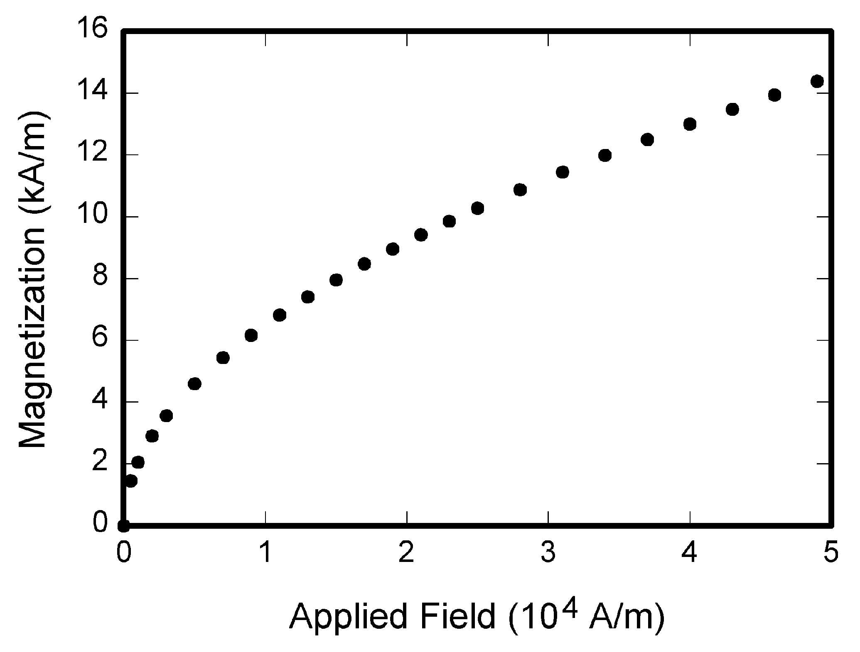

Figure 1. Magnetization as a function of applied field.
Note how the caption is centered in the column.

B. References

Number citations consecutively in square brackets [1]. The sentence punctuation follows the bracket [2]. Refer simply to the reference number, as in [3]. Do not use “Ref. [3]” or “reference [3]” except at the beginning of a sentence:
“Reference [3] shows ... .”

Number footnotes separately in superscripts. Place the actual footnote at the bottom of the column in which it was cited. Do not put footnotes in the reference list. Use letters for table footnotes (see Table I). IEEE Transactions no longer use a journal prefix before the volume number. For example, use “IEEE Trans. Magn., vol. 25,” not “vol. MAG 25.”
Please note that the references at the end of this document are in the preferred referencing style. Give all authors’ names; do not use “et al.” unless there are six authors or more. Use a space after authors' initials. Papers that have not been published, even if they have been submitted for publication, should be cited as “unpublished” [4]. Papers that have been accepted for publication should be cited as “in press” [5].
Capitalize only the first word in a paper title, except for proper nouns and element symbols. For papers published in translation journals, please give the English citation first, followed by the original foreign-language citation [6].

C. Abbreviations and Acronyms

Define abbreviations and acronyms the first time they are used in the text, even after they have already been defined in the abstract. Abbreviations such as IEEE, SI, MKS, CGS, ac, dc, and rms do not have to be defined. Abbreviations that incorporate periods should not have spaces: write “C.N.R.S.,” not “C. N. R. S.” Do not use abbreviations in the title unless they are unavoidable (for example, “IEEE” in the title of this article).

D. Equations

Number equations consecutively with equation numbers in parentheses flush with the right margin, as in (1). To make your equations more compact, you may use the solidus ( / ), the exp function, or appropriate exponents. Use a long dash rather than a hyphen for a minus sign. Use parentheses to avoid ambiguities in denominators. Punctuate equations with commas or periods when they are part of a sentence, as in

A + B = C. (1)

Be sure that the symbols in your equation have been defined before the equation appears or immediately following. Italicize variables (T might refer to temperature, but T is the unit tesla). Refer to “(1),” not “Eq. (1)” or “equation (1),” except at the beginning of a sentence: “Equation (1) is ... .”

E. Other Recommendations

The Roman numerals used to number the section headings are optional. If you do use them, number INTRODUCTION, but not ACKNOWLEDGMENT and REFERENCES, and begin Subheadings with letters. Use one space after periods and colons. Hyphenate complex modifiers: “zero-field-cooled magnetization.” Avoid dangling participles, such as, “Using (1), the potential was calculated.” Write instead, “The potential was calculated using (1),” or “Using (1), we calculated the potential.”
Use a zero before decimal points: “0.25,” not “.25.” Use “cm³,” not “cc.” Indicate sample dimensions as “0.1 cm × 0.2 cm,” not “0.1 × 0.2 cm².” The abbreviation for “seconds” is “s,” not “sec.” Do not mix complete spellings and abbreviations of units: use “Wb/m²” or “webers per square meter,” not “webers/m².” When expressing a range of values, write “7 to 9” or “7-9,” not “7~9.” Spell units when they appear in text: “…a few henries,” not “…a few H.” If your native language is not English, try to get a native English-speaking colleague to proofread your paper.

III. METHODOLOGY

Use either SI (MKS) or CGS as primary units. (SI units are strongly encouraged.) English units may be used as secondary units (in parentheses). This applies to papers in data storage. For example, write “15 Gb/cm² (100 Gb/in²).” An exception is when English units are used as identifiers in trade, such as “3.5-inch disk drive.”
Avoid combining SI and CGS units, such as current in amperes and magnetic field in oersteds. This often leads to confusion because equations do not balance dimensionally. If you must use mixed units, clearly state the units for each quantity that you use in an equation.

IV. (EXPECTED) FINDINGS AND DISCUSSION

Finally, you are responsible for language as editors will not check it. Do a spell and grammar check. This is available in Word. If English is not your native language, get a professional proof-reader to help if possible.
The word “data” is plural, not singular. The subscript for the permeability of vacuum µ₀ is zero, not a lowercase letter “o.” In American English, periods and commas are within quotation marks, like “this period.” A parenthetical statement at the end of a sentence is punctuated outside of the closing parenthesis (like this). (A parenthetical sentence is punctuated within the parentheses.) A graph within a graph is an “inset,” not an “insert.” The word “alternatively” is preferred to the word “alternately” (unless you really mean something that alternates). Use the word “whereas” instead of “while” (unless you are referring to simultaneous events). Do not use the word “essentially” to mean “approximately” or “effectively.” Do not use the word “issue” as a euphemism for “problem.”

V. CONCLUSION

Be aware of the different meanings of the homophones “affect” (usually a verb) and “effect” (usually a noun), “complement” and “compliment,” “discreet” and “discrete,” “principal” (e.g., “principal investigator”) and “principle” (e.g., “principle of measurement”). Do not confuse “imply” and “infer.”
Prefixes such as “non,” “sub,” “micro,” “multi,” and “ultra” are not independent words; they should be joined to the words they modify, usually without a hyphen. There is no period after the “et” in the Latin abbreviation “et al.” (it is also italicized). The abbreviation “i.e.,” means “that is,” and the abbreviation “e.g.,” means “for example” (these abbreviations are not italicized).

ACKNOWLEDGMENT

The preferred spelling of the word “acknowledgment” in American English is without an “e” after the “g.” Use the singular heading even if you have many acknowledgments. Avoid expressions such as “One of us (J.Q.A.) would like to thank ... .” Instead, write “J. Q. Author thanks ... .” Sponsor and financial support acknowledgments are placed in the unnumbered footnote on the first page.

REFERENCES

[1] D. J. Beebe, “Signal conversion (Book style with paper title and editor),” in Biomedical Digital Signal Processing, W. J. Tompkins, Ed. Englewood Cliffs, NJ: Prentice-Hall, 1993, ch. 3, pp. 61–74.
[2] M. Akay, Time Frequency and Wavelets in Biomedical Signal Processing (Book style). Piscataway, NJ: IEEE Press, 1998, pp. 123–135.
[3] G. B. Gentili, V. Tesi, M. Linari, and M. Marsili, “A versatile microwave plethysmograph for the monitoring of physiological parameters (Periodical style),” IEEE Trans. Biomed. Eng., vol. 49, no. 10, pp. 1204–1210, Oct. 2002.
[4] V. Medina, R. Valdes, J. Azpiroz, and E. Sacristan, “Title of paper if known,” unpublished.
[5] E. H. Miller, “A note on reflector arrays (Periodical style—Accepted for publication),” IEEE Trans. Antennas Propagat., in press.
[6] T. Menendez, S. Achenbach, W. Moshage, M. Flug, E. Beinder, A. Kollert, A. Bittel, and K. Bachmann, “Prenatal recording of fetal heart action with magnetocardiography” (in German), Zeitschrift für Kardiologie, vol. 87, no. 2, pp. 111–8, 1998.
[7] J. E. Monzon, “The cultural approach to telemedicine in Latin American homes (Published Conference Proceedings style),” in Proc. 3rd Conf. Information Technology Applications in Biomedicine, ITAB´00, Arlington, VA, pp. 50–53.
[8] F. A. Saunders, “Electrotactile sensory aids for the handicapped (Presented Conference Paper style),” presented at the 4th Annu. Meeting Biomedical Engineering Society, Los Angeles, CA, 1973.
[9] J. R. Boheki, “Adaptive AR model spectral parameters for monitoring neonatal EEG (Thesis or Dissertation style),” Ph.D. dissertation, Biomed. Eng. Program, Univ. Fed. Rio de Janeiro, Rio de Janeiro, Brazil, 2000.
[10] J. P. Wilkinson, “Nonlinear resonant circuit devices (Patent style),” U.S. Patent 3 624 12, July 16, 1990.

